Supplemental Genetics Figures

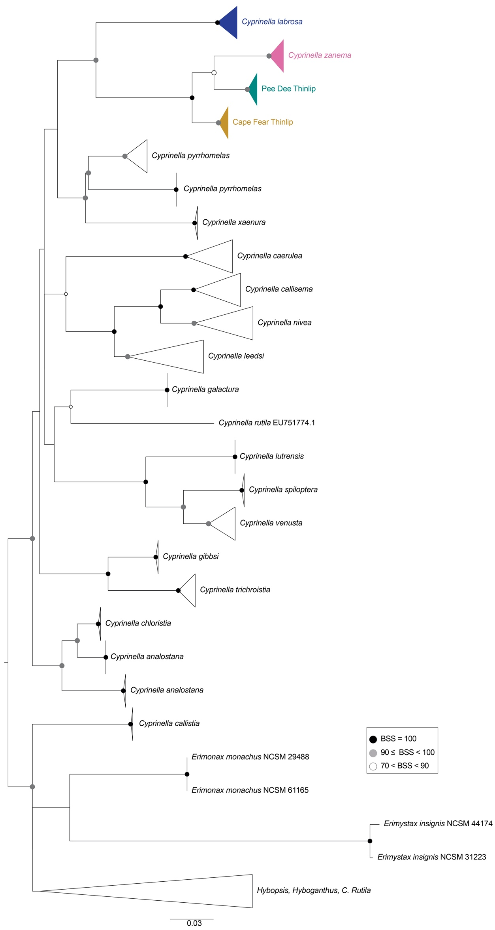

Figure S1. COI phylogeny for Cyprinella and outgroups. Thicklip Chub, Cyprinella labrosa, Santee Chub, C. zanema, and Yadkin-Pee Dee basin and Cape Fear basin Cyprinella leptocheilus sp. nov. Siouan Thinlip Chub, are denoted by blue, pink, teal, and yellow triangles, respectively. Bootstrap Support values are represented by black (BSS=100), gray (90 ≤ BSS < 100), and white circles (70 < BSS < 90).
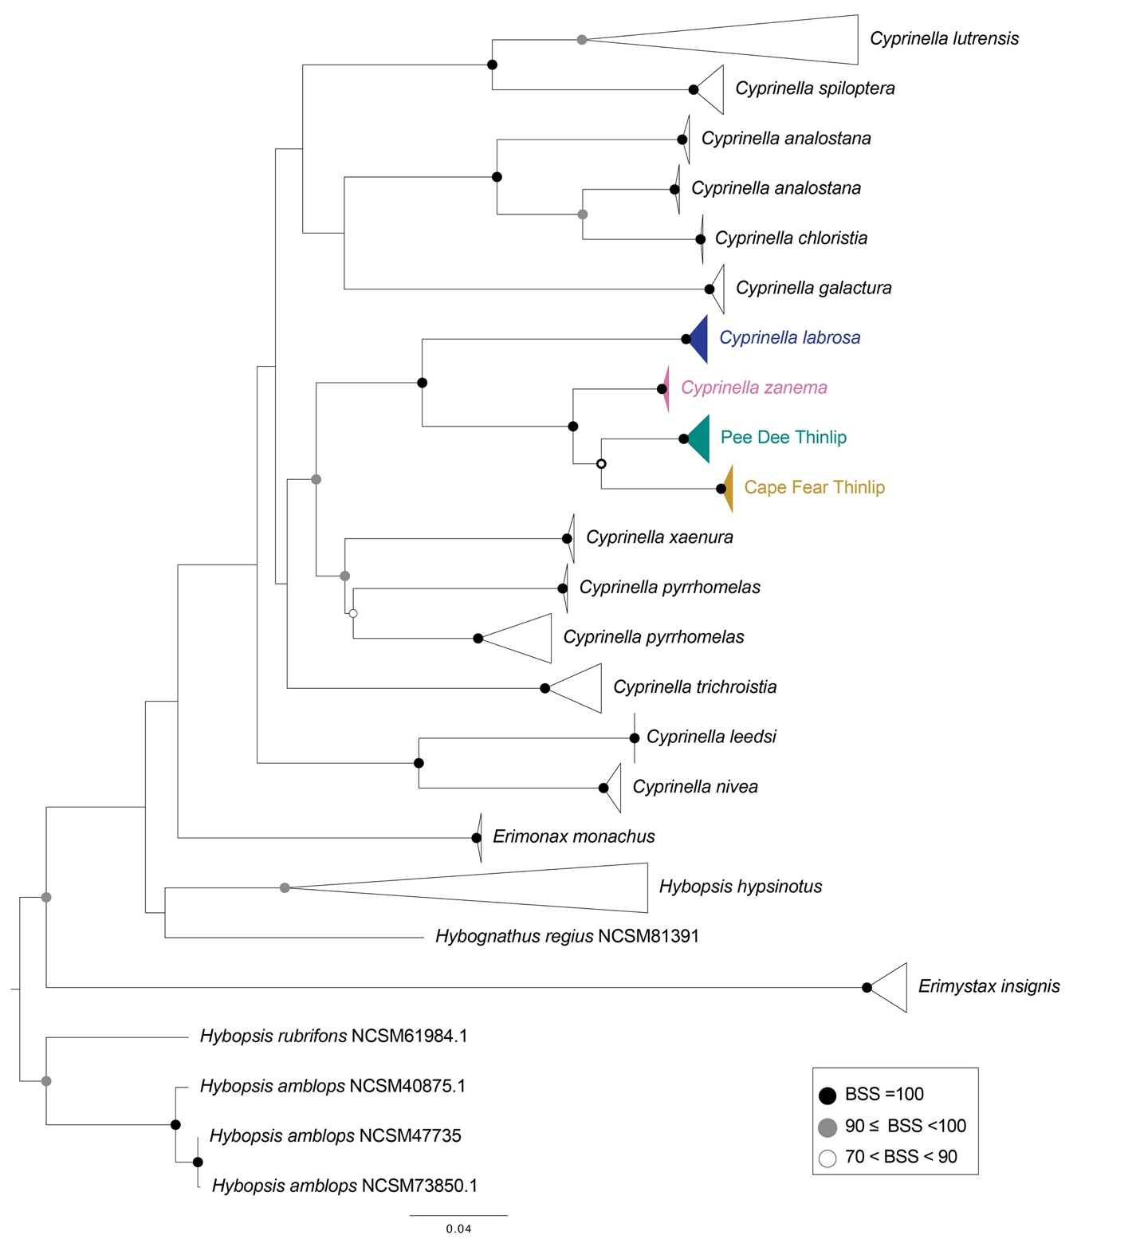

Figure S2. Cytochrome b phylogeny for Cyprinella and outgroups. Thicklip Chub, Cyprinella labrosa, Santee Chub, C. zanema, and Yadkin-Pee Dee basin and Cape Fear basin Cyprinella leptocheilus sp. nov. are denoted by blue, pink, teal, and yellow triangles, respectively. Bootstrap Support value are represented by black (BSS=100), gray (90 ≤ BSS < 100), and white circles (70 < BSS < 90).

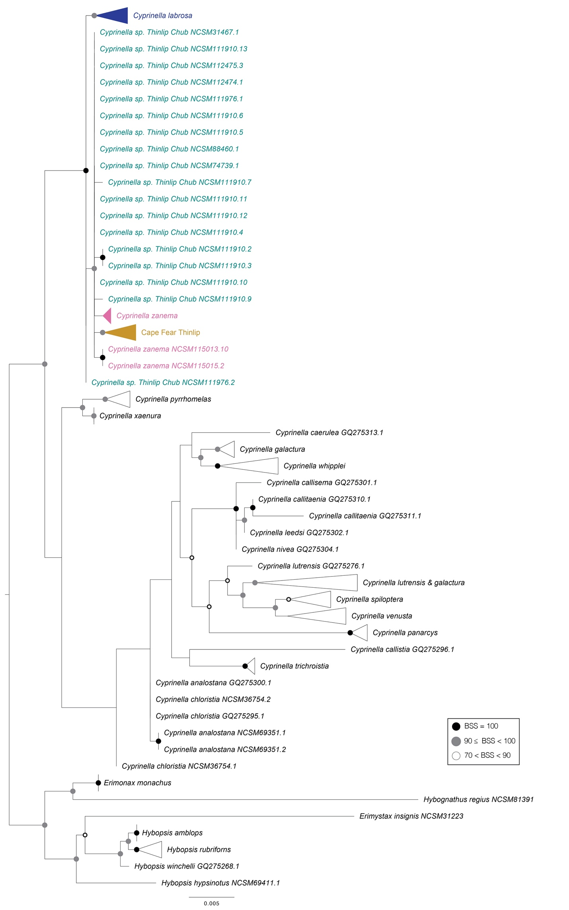

Figure S3. RAG1 phylogeny for Cyprinella and outgroups. Thicklip Chub, Cyprinella labrosa, Santee Chub, C. zanema, and Yadkin-Pee Dee basin and Cape Fear basin Cyprinella leptocheilus sp. nov. are denoted by blue, pink, teal, and yellow triangles and font colors, respectively. Bootstrap Support values are represented by black (BSS=100), gray (90 ≤ BSS < 100), and white circles (70 < BSS < 90).

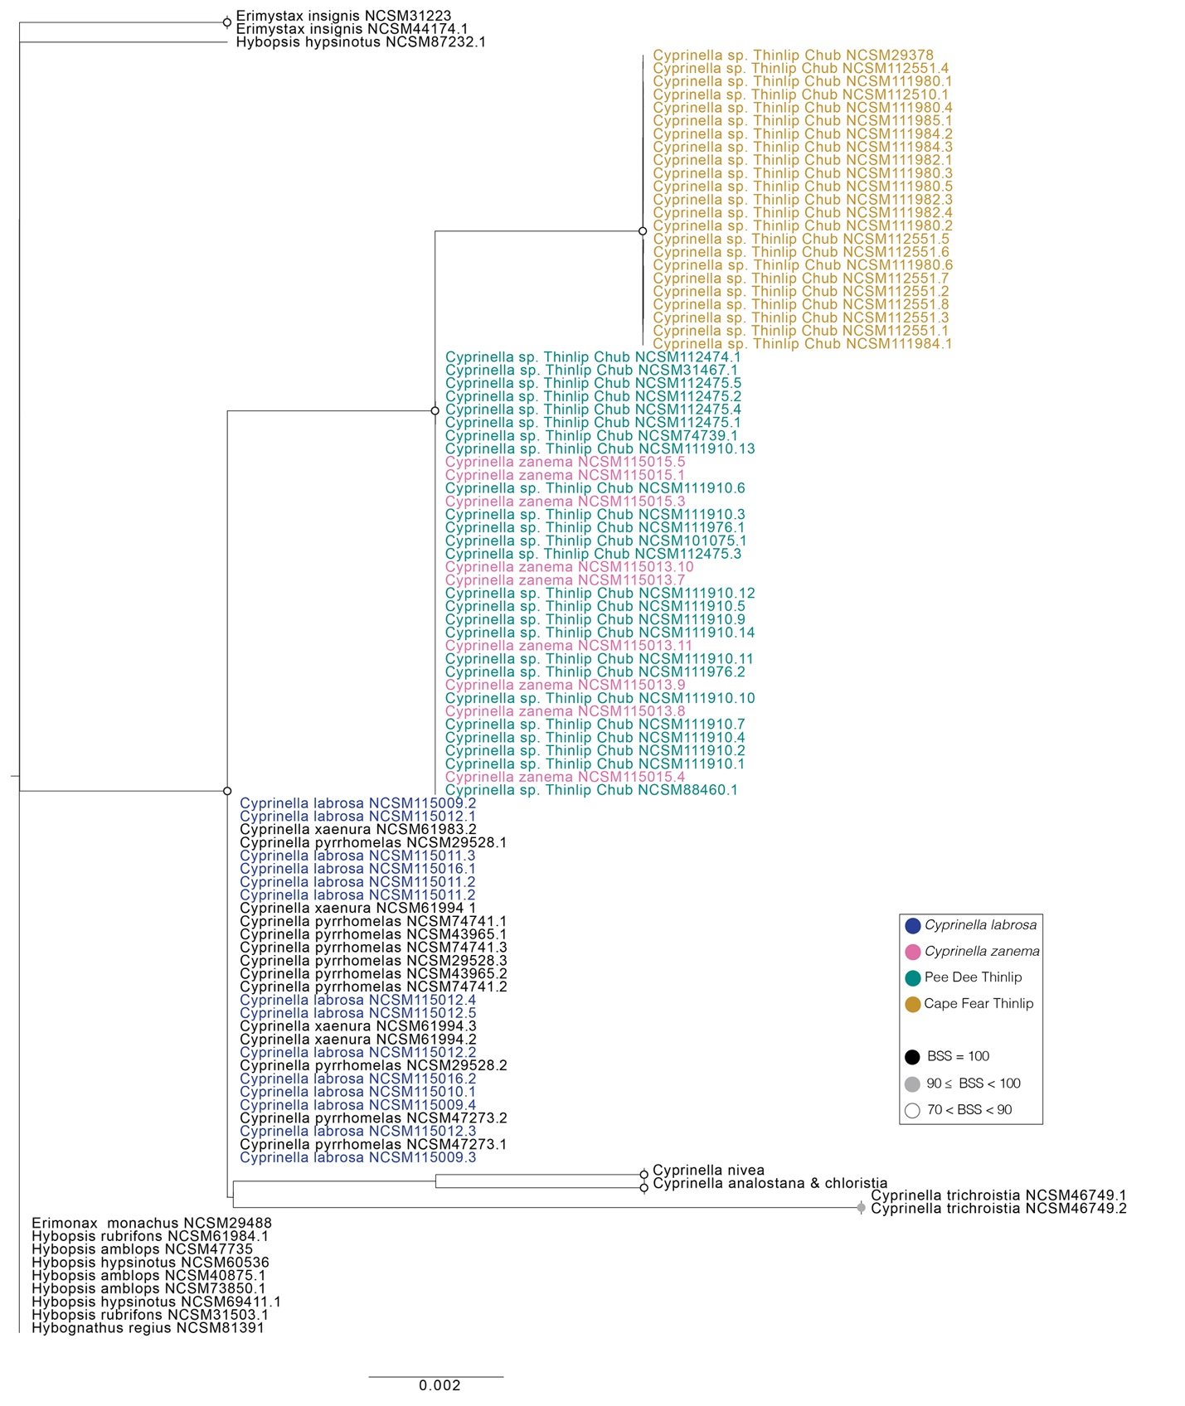

Figure S4. Homeobox13 phylogeny for Cyprinella and outgroups. Thicklip Chub, Cyprinella labrosa, Santee Chub, C. zanema, and Yadkin-Pee Dee basin and Cape Fear basin Cyprinella leptocheilus sp. nov. are denoted by blue, pink, yellow, and teal font colors, respectively. Bootstrap Support values are represented by black (BSS=100), gray (90 ≤ BSS < 100), and white circles (70 < BSS < 90).

